From Ancestry.com:
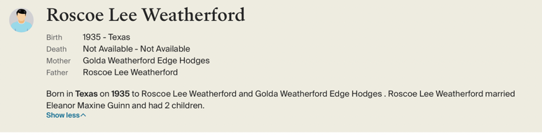
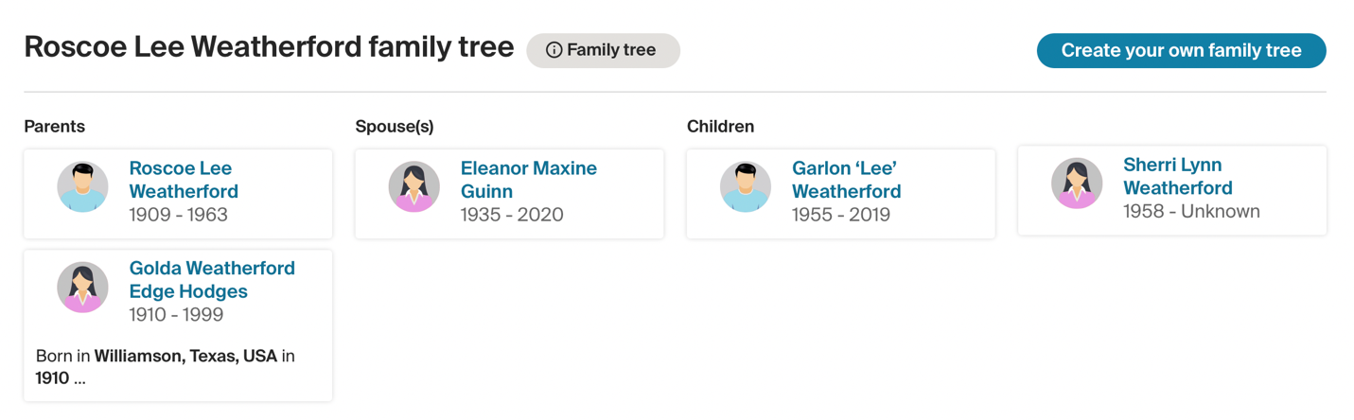

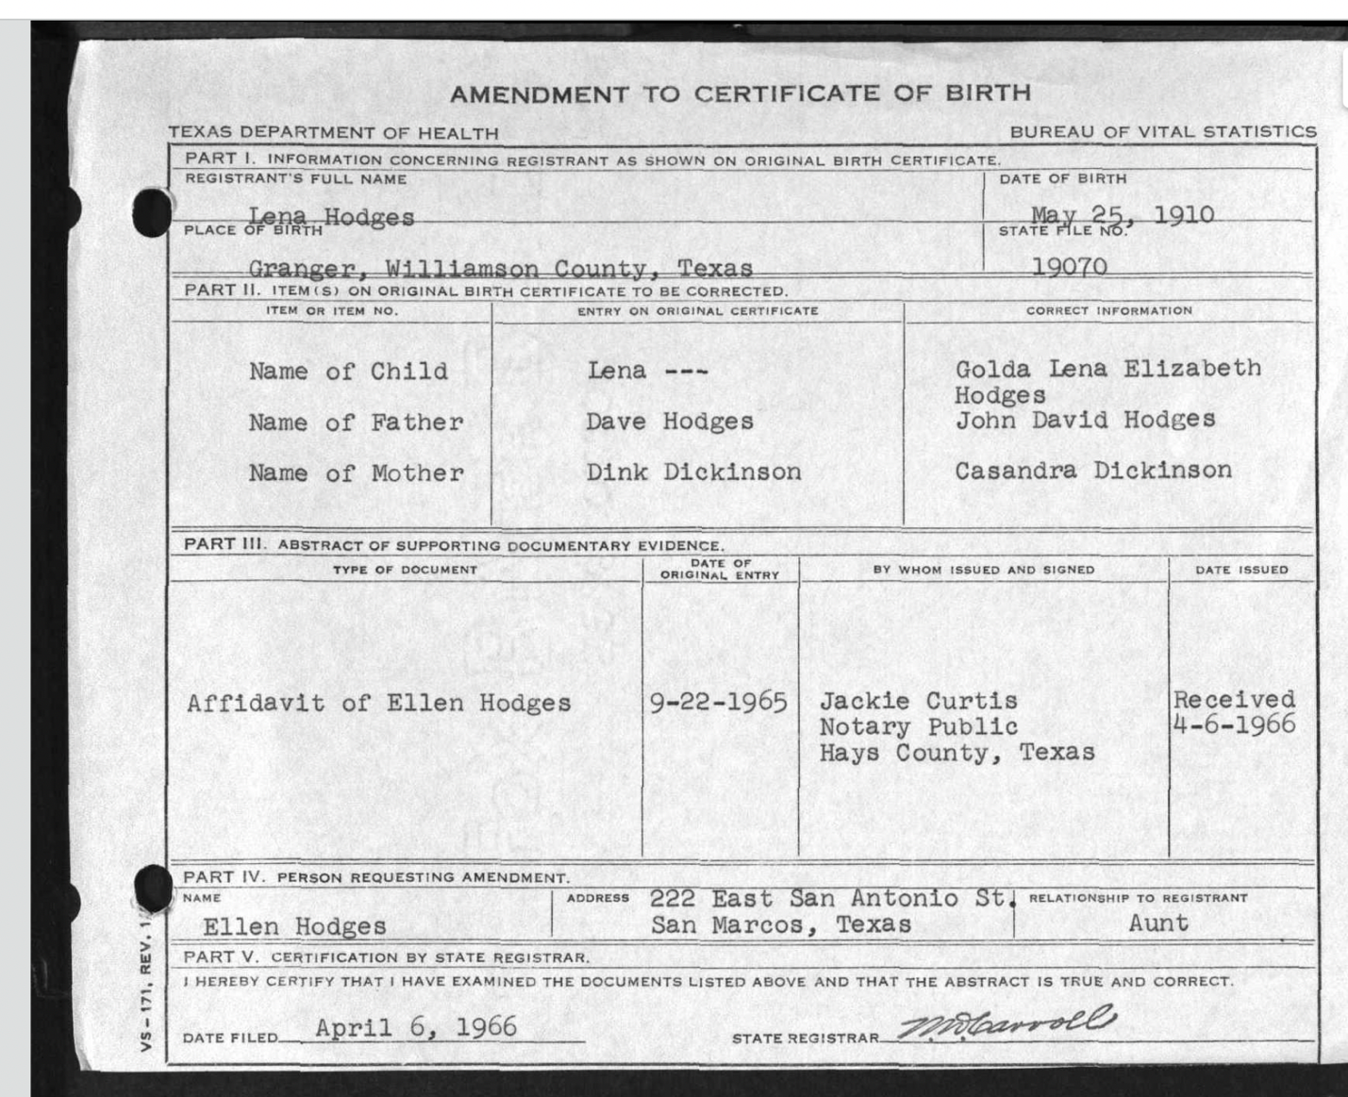

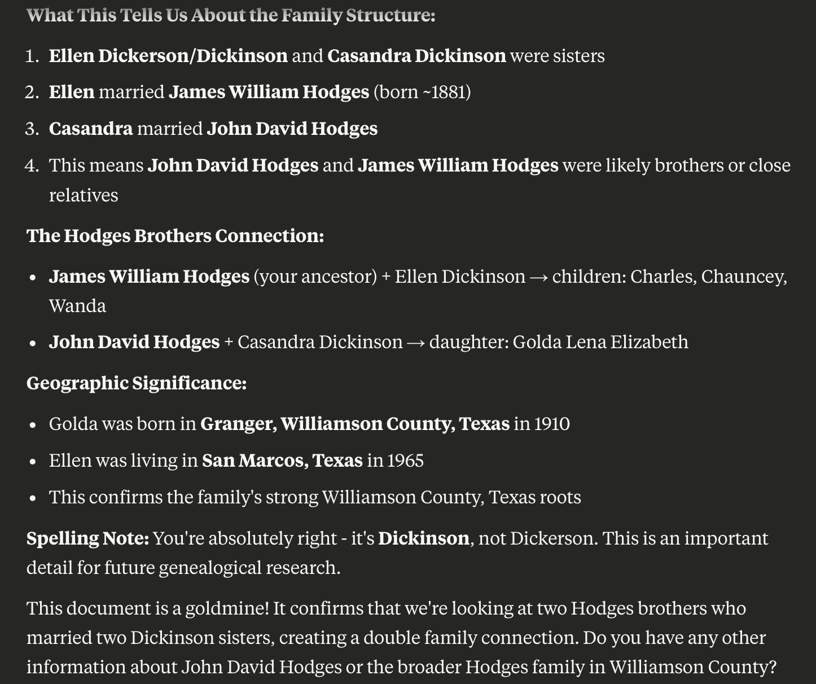

Golda’s father: John David Hodges (b. 1878 in Milam, TX, died 1944 in Bartlett, TX)
Golda’s mother: Dinah Casandra Dickinson (b. 1883, d. ?)
Siblings: Cecil David Hodges (1902-1981), Golda Lena Elizabeth Hodges (1910-1999)

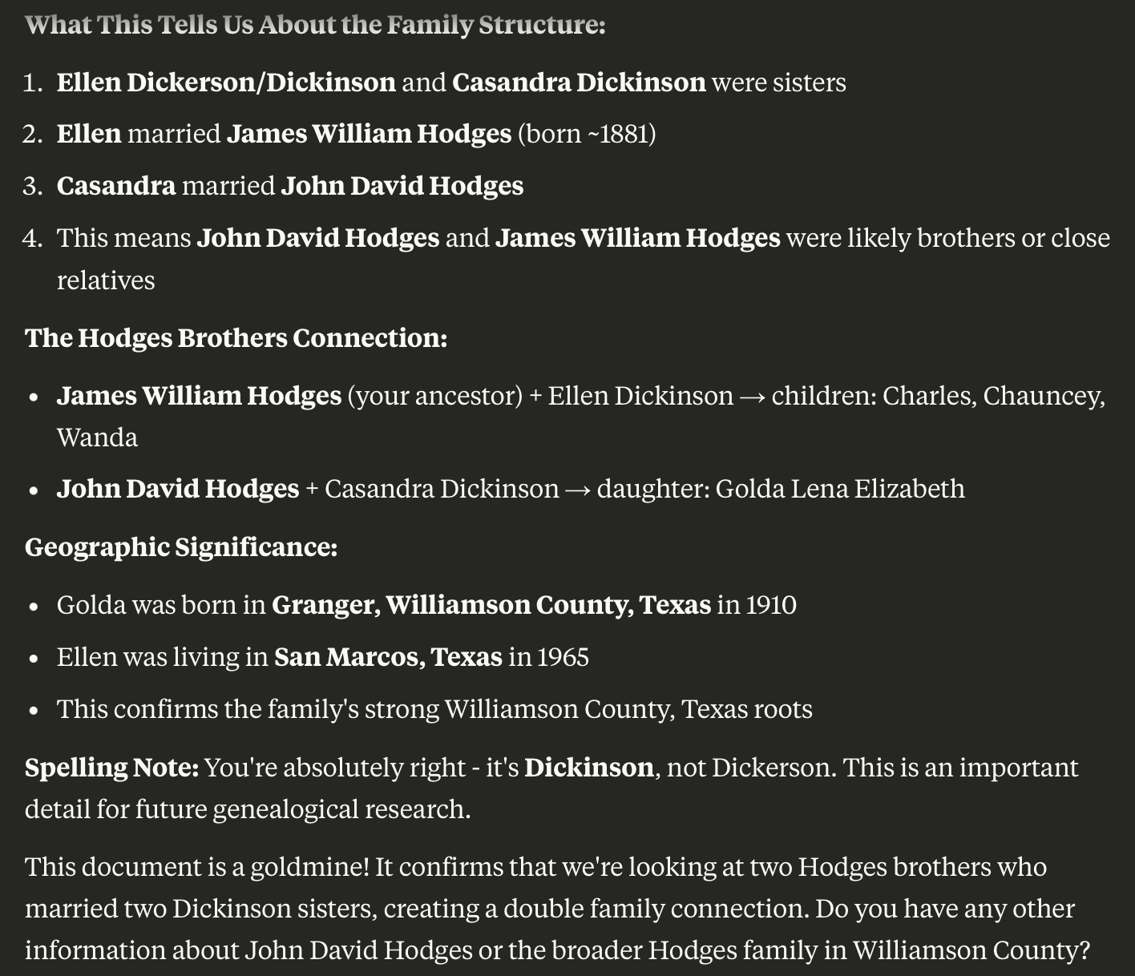

Ellen Dickinson’s might be related to:
Ref: https://lrl.texas.gov/legeleaders/members/memberdisplay.cfm?memberID=4984
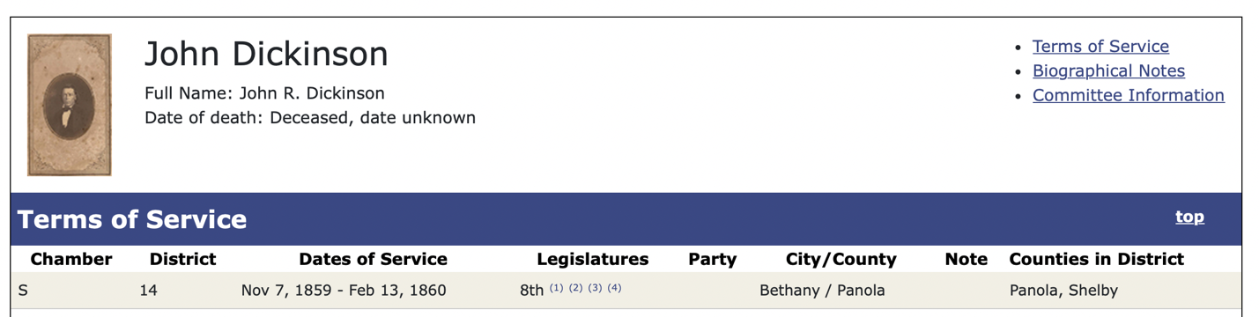
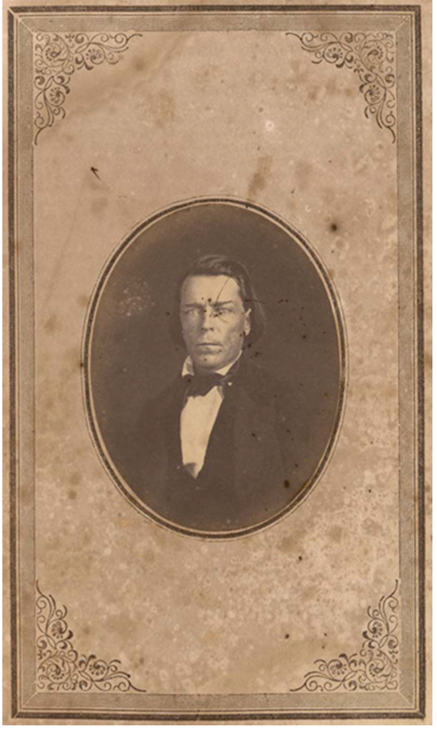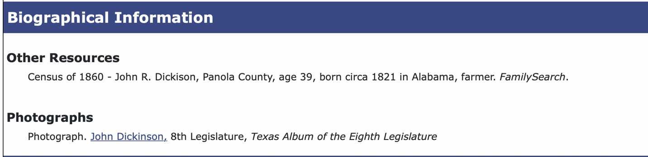

Excellent website that traces all of the Hodges lineages:
https://www.hodges-hodge-society.org/pats.htm?utm_source=chatgpt.com
Could ask Mark to take Y-DNA37 test

